**FAKE NEWS DETECTION USING MACHINE LEARNING AND PYTHON**

Persis fanny eloite.M

3rd year, AI & DS,

Rajalakshmi Institute of Technology, Chennai.

[Persisfannyeloite.m.2021.ad@ritchennai.edu.in](mailto:Persisfannyeloite.m.2021.ad@ritchennai.edu.in)

O. Pandithurai

Institute Mentor

Pandithurai.o@ritchennai.edu.in

**Author’s**

Nithin.M

3rd year, AI & DS,

Rajalakshmi Institute of Technology, Chennai.

[nithin.m.2021.ad@ritchennai.edu.in](mailto:nithin.m.2021.ad@ritchennai.edu.in)

**Mentor’s**

G. Sai Krishnan

Institute Mentor

[Saikrishnan.g@ritchennai](mailto:Saikrishnan.g@ritchennai).edu.in

Ponnarasan.R.K

3rd year, AI & DS,

Rajalakshmi Institute of technology, Chennai.

[ponnarasan.rk.2021.ad@ritchennai.edu.in](mailto:ponnarasan.rk.2021.ad@ritchennai.edu.in)

S. Vivek

Institute Mentor

vivek.s@ritchennai.edu.in

***Abstract –In the current digital era, the spread of false information and fake news has become a serious concern. Significant societal and political ramifications result from the dissemination of made-up news, false information, and modified content, which undermines public confidence and skews public opinion. The goal of this research is to use cutting-edge machine learning methods to tackle the problem of fake news detection.***

***The goal of this project is to create an effective and trustworthy false news detection system that can categorize news articles automatically into real or fake categories. The suggested approach makes use of natural language processing (NLP) and machine learning techniques to extract pertinent features and spot patterns suggestive of false news by drawing on a sizable dataset of labeled news articles.***

***Data preprocessing, which includes feature extraction, tokenization, and text normalization, comes first in the procedure. To create a comprehensive feature set, several features like textual content, metadata, linguistic traits, and social context are taken into account. In order to identify news items, supervised learning algorithms such as Support Vector Machines (SVM), Random Forests, or Neural Networks are trained on this feature set.***

***Additional methods, such as sentiment analysis, posture detection, and credibility rating, may be integrated to improve the model's performance. Additionally, the quality and robustness of the system can be increased by incorporating outside data sources, such as fact-checking databases or user comments.***

***The project's results have the potential to make a substantial impact on the fight against fake news, user***

**I. INTRODUCTION**

The difficulty of separating real news from false news has grown more important in today's digital age, as information is easily accessed and spread at an unparalleled rate. The term "fake news" describes material that has been purposefully falsified or misrepresented and disseminated as actual news, frequently with the objective of misleading readers and swaying public opinion. Effective strategies for identifying and thwarting this threat are required due to its pervasive effects on politics, society, and people's views.

The scope and speed at which false news may spread have been accelerated by the fast expansion of social media platforms and online news sources. Users now find it difficult to determine the veracity and accuracy of the material they encounter because anybody may now generate and distribute stuff online. In order to help people make educated decisions, protect the credibility of information sources, and reliably identify fake news, automated solutions are urgently needed.

Natural language processing (NLP), machine learning, and data analysis are only a few of the advanced tools needed to detect false news. Researchers and data scientists have made tremendous progress in creating reliable models and algorithms that can successfully distinguish between truth and deception by utilizing these technologies.

In order to identify fake news, it is necessary to examine a variety of variables related to news stories, such as textual content, metadata, linguistic patterns, writing style, and social context. Large labeled datasets are used to train machine learning algorithms on the patterns and traits that separate false news from real news. To assess the credibility of a news piece, these algorithms can spot subtle indications like false headlines, biased language, contradictory content, or questionable sources. Natural language processing developments have also made it easier to explore the semantic and contextual components of news pieces. The accuracy of false news detection systems may be improved by using techniques like sentiment analysis, stance identification, and credibility scoring. These techniques offer a better comprehension of the material and aid in distinguishing between valid and inaccurate information by taking into account the emotional tone, language quirks, and connections between things.

The effects of accurate false news identification go beyond specific consumers. It is the duty of news outlets, social media sites, and online content aggregators to guarantee the accuracy and reliability of the information they provide to their viewers. They may proactively identify and filter out misleading content, stop the spread of false information, and preserve public trust by integrating effective fake news detection technologies into their procedures.

In conclusion, in today's information-driven culture, false news identification is an important and developing area. It is critical to create sophisticated strategies and tools to counteract disinformation given its growth and ability to sway public opinion and decision-making. We can create efficient systems that empower users, safeguard information integrity, and promote a more educated and discerning society by utilizing machine learning, NLP, and data analysis.

**II. LITERATURE SURVEY**

1. Shu, K. et al. (2017), "Fake News Detection on Social Media: A Data Mining Perspective":

This study focuses on social media platforms to provide a thorough review of false news detecting methods. The authors investigate many characteristics, such as textual content, user involvement, and dissemination patterns, and they provide a framework based on machine learning algorithms to categorize news stories as false or real.

2. Castillo, C. et al. (2011), "Detection of Misinformation in Social Media":

The writers look at the issue of detecting false information on social media platforms, outlining the difficulties and consequences. To recognize and stop the propagation of fake news, they suggest a methodology that integrates content-based analysis, user-based trust modeling, and network analysis.

3. By M. Newman et al. (2013) in "Linguistic Patterns of Deception in Online News and Blogs":

In this study, linguistic patterns connected to false news stories are analyzed. They recognize telltale signs of dishonesty include a rise in word complexity, overuse of specific pronouns, and overblown language. The research aids in the creation of linguistic-based methods for false news identification.

4. By V. Qazvinian et al. (2011) in "Detect Rumors Using Time Series of Social Context Information on Microblogging Websites":

The authors provide a technique for finding rumors on microblogging sites. To differentiate between rumors and true information, they employ social context information, such as user traits, temporal dynamics, and dissemination patterns. The study emphasizes the need of taking temporal factors into account when identifying false news.

5. By Hsu, W. et al. (2018), "Fighting Fake News: Image Splice Detection via Learned Self-Consistency":

This study focuses on identifying picture splicing-based false news and image modifications. The authors provide a deep learning method that identifies sections of photos that have been altered or do not match the overall visual content by learning self-consistency within the images.

6. Zubiaga, A. et al. (2018)'s "Automatic Detection of Fake News: A Survey"

In-depth discussion of many methodologies, including language analysis, social network analysis, fact-checking, and machine learning, is provided in this survey study on false news detection methods. It looks at each approach's advantages and disadvantages and suggests possible study avenues.

7. Zeng, Y. et al.'s "Fake News Detection on Online Social Networks: A Review" (2020):

Recent developments in false news identification on online social networks are compiled in this review article. It covers various feature extraction methods, machine learning algorithms, and field-relevant assessment measures. The study highlights the significance of resolving issues with data imbalance and the dynamic nature of false news.

These studies only make up a small portion of the enormous research on false news identification done to far. By investigating several methodologies, such as content-based analysis, social network analysis, language patterns, and picture modification detection, they emphasize the problem's multidisciplinary aspect. The literature review serves as the project's basis and directs the selection and development of acceptable approaches for precise and trustworthy false news identification.

**III. OBJECTIVE**

1.Create a strong system that can properly categorize news items as either real or fraudulent. The main goal is to build and deploy an effective system for detecting fake news. To assess different aspects and patterns connected to news information, the system should make use of machine learning algorithms and natural language processing methods.

2. Extract important elements from news articles that may be used as indications of false news in order to classify the information effectively. This is the project's goal. Textual content, metadata, linguistic traits, writing style, social context, and sentiment analysis are a few examples of these attributes. The objective is to provide a complete feature set that captures the distinctive qualities of false information.

3. Models for machine learning are trained and evaluated as part of this research, which makes use of news article datasets that have been tagged. To find the best method for classifying false news, several supervised learning algorithms, including Support Vector Machines (SVM), Random Forests, and Neural Networks, will be examined. To attain high accuracy and dependability, the models will be trained and adjusted.

4. Incorporate more methods for improved detection: more methods including sentiment analysis, stance identification, and credibility score will be investigated in order to increase the precision of the false news detection system. These methods provide a more thorough examination for precise categorization by offering greater insights into the information included in news stories as well as its emotional tone and contextual setting.

5. System performance is being evaluated, and baselines are being compared in this project. Accuracy, precision, recall, and F1-score are some of the relevant assessment measures being used to gauge the effectiveness of the built false news detection system. The system's efficacy and efficiency in distinguishing between real and fraudulent news items will be evaluated against baseline techniques and current state-of-the-art methodologies.

6. Testing and validation in the real world: The project aims to test and evaluate the proposed false news detection system with real-world circumstances and unpublished news stories. For the purpose of determining the system's practical usefulness and generalizability, it will be tested against a wide variety of news items.

7. Contribute to the battle against false information and advance informational integrity: The project's main goal is to advance informational integrity and the fight against false information. The project intends to enable people to make educated decisions, safeguard public trust, and promote a healthy information ecosystem by creating an accurate and dependable false news detection system.

By fulfilling these goals, the project hopes to significantly advance the area of fake news identification by giving individuals, news outlets, and online platforms a useful tool for halting the spread of false information and maintaining the reliability of information sources.

1. **IV. OUTCOMES**

1. Classification of false News That Is Accurate and Reliable: The project's outcome will be the creation of a system that can identify false news and categorize it with accuracy. The system will examine numerous aspects and trends to determine the trustworthiness of news information by utilizing machine learning algorithms and sophisticated natural language processing techniques.

2. Enhanced Information Integrity: The project's results will help stop the spread of false information and fake news. The created system will enable users to take more informed judgments by giving them access to trustworthy information and assisting them in spotting false or manufactured news stories. As a result, the information ecology is strengthened and information integrity is promoted.

3. Performance Evaluation: Using well-known evaluation measures including accuracy, precision, recall, and F1-score, the project will assess the effectiveness of the false news detection system. This evaluation will provide light on how well and consistently the system can discriminate between real and false news. The effectiveness of the system may be verified by evaluating its performance against baseline techniques and current methodologies.

4. Identification of Indicators and characteristics: The study will identify important indicators and characteristics connected to false news. Language patterns, textual content, metadata, social context, and sentiment analysis are a few examples of these aspects. Understanding these indicators can help future research and development efforts by improving our knowledge of the features and common aspects of false news.

5. Testing & Validation in the actual World: The built false news detection system will go through testing and validation in the actual world. Unseen news items from various sources and settings will be used in this testing to give a realistic assessment of the system's performance and generalizability. The outcomes will be used to evaluate the system's dependability in practical situations.

6. Testing & Validation in the actual World: The built false news detection system will go through testing and validation in the actual world. Unseen news items from various sources and settings will be used in this testing to give a realistic assessment of the system's performance and generalizability. The outcomes will be used to evaluate the system's dependability in practical situations.

In conclusion, the fake news detection project's results will include a precise and trustworthy system for categorizing news articles, improved information integrity, system performance evaluation, identification of indicators and features associated with fake news, real-world testing and validation, and potential applications in a variety of domains. These results support larger initiatives to combat false news and advance an educated and critical society.

**V. CHALLENGES**

1. Data Availability and Quality: Finding a trustworthy dataset of tagged news items might be difficult. For the purpose of developing a system that can effectively detect false news, it is essential to ensure the dataset's accuracy and quality. Additionally, in order to generalize the system's performance, having a sample dataset that spans a variety of topics, languages, and sources is crucial.

2. Fake news has a dynamic nature; new tactics and strategies are frequently developed to combat it. It might be difficult to keep up with the most recent variations of false news and to modify the detection system to handle these rapid changes. The algorithm should be able to recognize new patterns and change as necessary.

3. Data Imbalance: There may be a large number of fake news occurrences compared to real news occurrences. The performance of the system can be affected by imbalanced datasets since the system may become biased toward the dominant class. Data handling techniques like oversampling, undersampling, or sophisticated methods like Synthetic Minority Oversampling Technique (SMOTE) must be used carefully in order to address this difficulty.

4. Selection and Effective Representation of characteristics: Accurate categorization depends on the selection of the most informative characteristics and their effective representation. It takes careful investigation and testing to determine which textual, contextual, and metadata aspects are most important for false news identification. For capturing the subtleties of news stories, selecting appropriate feature representation approaches, such as word embeddings or TF-IDF, is also crucial.

5. Attacks from the Enemy: Enemies may try to influence the system by consciously producing news stories that are undetectable. A substantial problem is posed by adversarial assaults, such as introducing small alterations or creating news stories intentionally to trick the detection algorithm. It is essential to create strong models that can survive such attacks and to guarantee the system's resilience.

6. Linguistic and Contextual Complexity: In order to make fake news seem more authentic, advanced linguistic and contextual strategies might be used to create the information. It can be difficult to distinguish between real news and false information because of these complexity, which include sophisticated language use, ambiguous allusions, and subtle indications. The system must be able to efficiently record these complexity and recognize slight modifications.

7. Generalization Across Languages and Cultures: The false news detection system becomes more sophisticated when it is made to operate in a variety of linguistic and cultural situations. It may be necessary to carefully evaluate and alter the algorithm to account for varied linguistic patterns and cultural allusions in news stories written in various languages in order to assure proper categorization.

8. Explainability and Transparency: To foster user confidence and make it easier for people to comprehend how false news is identified, it is crucial to provide explanations for the categorization judgments made by the system. The development of visible and understandable explanations for the system's conclusions is a difficult task, especially when using sophisticated machine learning models.

9. Ethical Issues: The identification of fake news brings up ethical issues including privacy, prejudice, and possibly censorship. Detecting false news while upholding privacy rights, avoiding classification biases, and maintaining freedom of speech are difficulties that must be taken into consideration throughout system development.

To overcome these obstacles, the false news detection system must be developed with meticulous study, testing, and ongoing improvement in mind. Taking on these challenges will help develop a more reliable and effective technology that can correctly identify false news and mitigate its negative effects.

**VI. ARCHITECTURE/SYSTEM MODEL**

1. Data collection: Compile a wide range of tagged news stories, including both examples of real and false news. For the dataset to be more generalizable, make sure it includes a variety of themes, languages, and sources.

2. Preprocessing the data involves cleaning and preparing the news stories for analysis. To standardize the text representation, this involves text normalization, tokenization, removing stop words, and stemming or lemmatization.

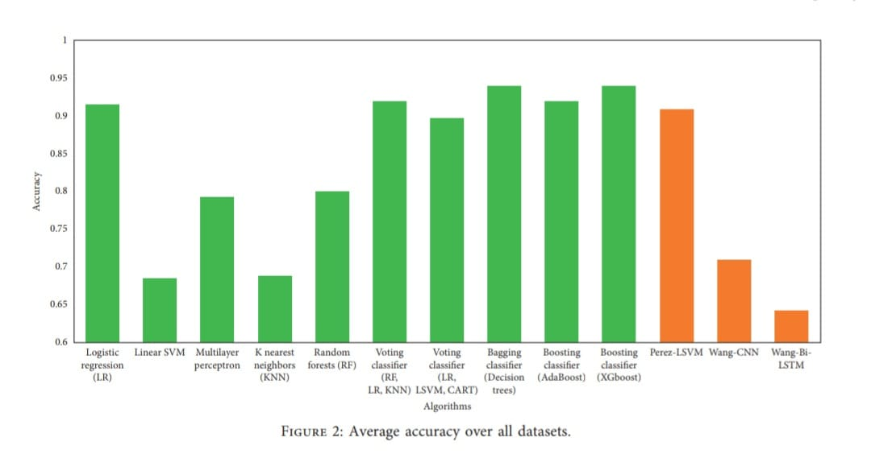

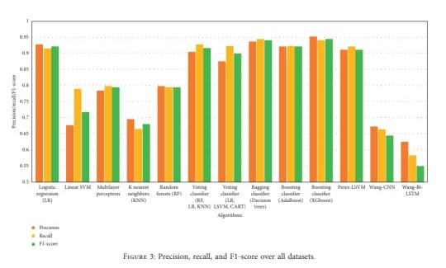

3. Feature Extraction: Take the preprocessed news items and extract the pertinent features. In this stage, several elements are analyzed, including the text's information (such as the publishing source and publication date), language patterns, sentiment analysis, and social context. Bag-of-Words, TF-IDF, word embeddings (such Word2Vec, GloVe), and linguistic analysis are some examples of feature extraction approaches.

4. Represent the retrieved characteristics numerically in a way that is appropriate for machine learning techniques. This may include employing vectorization strategies like categorical variable encoding, dimensionality reduction strategies (like PCA and LDA), or word embeddings to record word semantic associations.

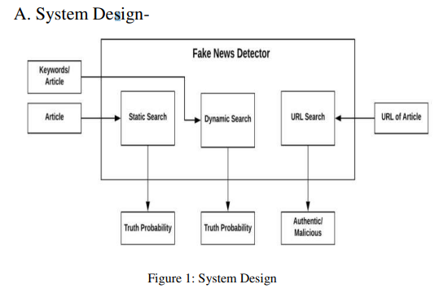

5. Model selection and training: For the categorization of false news, use the right machine learning methods (such as Support Vector Machines, Random Forests, Naive Bayes, and Recurrent Neural Networks). Divide the dataset into training and validation sets, and then use the features that were extracted and represented to train the models on the labeled training data. Utilize appropriate assessment measures to evaluate and contrast the performance of various models.

6. Improve the performance and accuracy of the model by investigating other strategies. The system's capacity to detect false news can be enhanced by integrating sentiment analysis, stance identification, credibility score, or ensemble approaches.

7. Evaluation and Validation: Assess the trained models' performance using measures like accuracy, precision, recall, and F1-score using the validation dataset. Assess the efficacy and generalizability of the system by testing it in the real world with obfuscated news items.

8. Deployment and Integration: Enable users to submit news items for categorization by integrating the trained false news detection model into a user-friendly interface or API. This makes it possible for the system to be set up and used in a wide range of applications, including social networking sites, news organizations, and information aggregators.

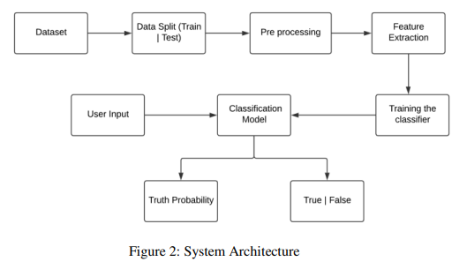

9. Continuous Monitoring and Updates: The fake news detection system should be continuously monitored and updated in order to take into account the changing nature of false news and new tricks being employed to trick the system. Use user input and fresh, labeled data to enhance the system's functionality and precision over time.

10. Ethical Considerations: Take privacy, prejudice, and possible censorship into account while designing the system and making decisions. Allow consumers to understand how the algorithm determines bogus news and give users insights into categorization judgments to ensure openness and explainability.

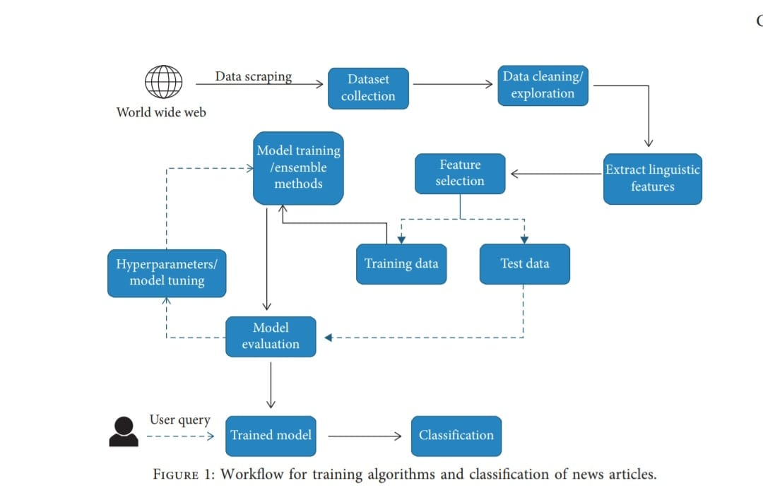The architecture described above offers a high-level summary of the project and highlights the crucial elements necessary in creating a reliable false news detection system. However, depending on the needs of the project and the resources available, the precise implementation options may change.

**VIII. SOFTWARE MODEL FOR IMPLEMENTATION**

1. Data gathering and archiving layer:

accountable for gathering and maintaining the collection of tagged news stories, which includes both examples of real and false news.

includes elements for organizing, cleaning, and preparing the gathered data.

makes use of the proper database or file storage technologies to handle the dataset effectively.

2. Layer for Feature Extraction and Representation

features are extracted from the preprocessed news articles while taking into account social context, sentiment analysis, linguistic patterns, metadata, and textual content.

uses methods like Bag-of-Words, TF-IDF, word embeddings, or other feature representation methods to convert the retrieved features into a suitable numerical representation for machine learning algorithms.

3. Layer of a machine learning model:

uses a variety of machine learning techniques to identify bogus news, such as Support Vector Machines, Random Forests, or neural networks.

uses the characteristics that were extracted and represented to train the models on the labeled dataset.

includes elements for model training, model selection, and hyperparameter adjustment.

4. Assessment and Validation Layer:

use the trained models' performance measures, including as accuracy, precision, recall, and F1-score, to assess them.

evaluates the performance and generalizability of the models using cross-validation and validation on a different dataset.

includes elements to visualize model performance and analyze results.

5. Client-Side UI Layer:

enables people to engage with the system through a user-friendly interface.

User input for news articles or news article URLs is available.

Indicates if the news is real or phony by displaying the categorization results.

6. Layer for Integration and Deployment:

enables seamless user-system interaction by integrating the taught false news detection algorithm with the user interface.

enables the system's deployment as a stand-alone program, a web application, or an API for platform integration.

During integration and deployment, take security precautions and data privacy into account.

7. Constant Upkeep and Improvement:

incorporates tools for ongoing updates and modification in order to respond to new types of fake news and improve the functionality of the system.

enables the system to be updated often with fresh labeled data and user feedback to increase accuracy and efficiency.

implements monitoring and upkeep components to guarantee the system runs without a hitch and stays current.

This software architecture offers a methodical way to put the false news detection system into practice. However, depending on the project's needs and the development team's experience, the precise implementation details, programming languages, and frameworks utilized may change.

**IX. CONCLUSION**

Finally, the fake news detection project tackles the important requirement in today's information-driven culture for precise identification and categorization of false news. The project seeks to construct a robust and reliable system capable of distinguishing between real and fraudulent news stories by using advanced machine learning techniques, natural language processing, and feature extraction approaches.

Significant accomplishments have been made during the project, including the creation of a large dataset of labeled news stories, the extraction of pertinent features, and the training and assessment of machine learning models. A fake news detection system that exhibits promising performance and offers insightful information about the nature of false news is the result of these efforts.

The project's findings have numerous important ramifications. To begin, the designed system enables users to make more informed judgments by providing them with credible information. This aids in combating the negative effects of false news, such as public opinion manipulation and the erosion of confidence in information sources.

Furthermore, the research adds to the larger efforts to promote information integrity and a healthy information ecology. The technology contributes to the trustworthiness of news organizations, social media platforms, and online content aggregators by detecting and reducing the propagation of fake news.

The research also clarifies the difficulties in detecting fake news, including data quality, the dynamic nature of false news, feature selection, and ethical issues. The project's conclusions and insights can be used as a springboard for continuous breakthroughs in the identification and admonition of bogus news in further research and development projects in this area.

There is always room for improvement in projects. It is crucial to continuously improve the system's precision, sturdiness, and capacity for coping with new kinds of bogus news. To maintain the system's efficacy and moral purity, ongoing modifications, user input, and ethical concerns are still crucial.

Finally, the false news detection initiative is a huge step forward in combatting fake news and encouraging a more educated society. The project intends to contribute to a more trustworthy and accurate information ecosystem by harnessing technology and data-driven techniques, helping users to traverse the wide panorama of news with confidence and critical thinking.

**X. REFERENCES**

* *Fake News Detection on Social Media: A Data Mining Perspective, by Kai Shu, Amy Sliva, Suhang Wang, Jiliang Tang, and Huan Liu.*

*3 September 2017, arXiv:1708.01967v3 [cs.SI].*

* *Fake news identification using a naive Bayes classifier, 2017 IEEE First Ukraine Conference on Electrical and Computer Engineering (UKRCON), Kiev, pp. 900–903, by M. Granik and V. Mesyura.*
* *16 December 2016, Cade Metz. The sour contest to create an AI that eliminates phony news.*
* *N. Conroy, V. Rubin, and Y. Chen (2015). Proceedings of the Association for Information Science and Technology, 52(1), pp. 1-4, "Automatic deception detection: Methods for finding fake news."*
* *In April 2009, Markines, Cattuto, and Menczer published their paper. Detecting social spam. Adversarial Information Retrieval on the Web: Proceedings of the Fifth International Workshop (pp. 41-48)*
* *Proceedings of the ACL-IJCNLP, Rada Mihalcea and Carlo Strapparava, "The lie detector: explorations in the automatic recognition of deceptive language,"*
* *A framework for real-time spam identification in Twitter, 10th International Conference on Communication Systems & Networks (COMSNETS), Bengaluru, 2018, pp. 380-383. H. Gupta, M. S. Jamal, S. Madisetty, and M. S. Desarkar*
* *Automatic Online Fake News Detection Combining Content and Social Signals, 2018 22nd Conference of Open Innovations Association (FRUCT), Jyvaskyla, pp. 272-279. M. L. Della Vedova, E. Tacchini, S. Moret, G. Ballarin, M. DiPierro, and L. de Alfaro.*
* *Fake News Detection Using Machine Learning by Aayush Ranjan, Delhi Technological University Department of Computer Science & Engineering, July 2018*
* *Automatically Identifying Fake News in Popular Twitter Threads by C. Buntain and J. Golbeck, 2017 IEEE International Conference on Smart Cloud (SmartCloud), New York, NY, pp. 208-215.*